Java Promblemsheet - 3

Name: Kaaviya S S Roll. no: 22PT15

1) Write a program that prompts the user for an integer, then asks the user to enter that many values. Store these values in an array and print the array. Then reverse the array elements so that the first element becomes the last element, the second element becomes the second to last element, and so on, with the old last element now first. Do not just reverse the order in which they are printed; actually change the way they are stored in the array. Do not create a second array; just rearrange the elements within the array you have.

import java.util.Scanner;

public class ArrayReverse {
public static void main(String args[]) {

Scanner obj = new Scanner(System.in);

System.out.print("Enter no. of elements in array: ");
int n = obj.nextInt();

int[] arr = new int[n];
System.out.println("Enter the elements in array: ");
for(int i=0;i<n;i++) {
arr[i] = obj.nextInt();
}

System.out.println("The Entered array is: ");
for(int i=0;i<n;i++) {
System.out.print(arr[i] + " ");
}
System.out.println("");

int a=0;
int b=n-1;
while(a<=b) {
//swap the elements
int t = arr[a];
arr[a] = arr[b];
arr[b] = t;

a++;
b--;
}

System.out.println("Reversed Array is: ");
for(int i=0;i<n;i++) {
System.out.print(arr[i] + " ");
}
System.out.println("");

obj.close();

}
}

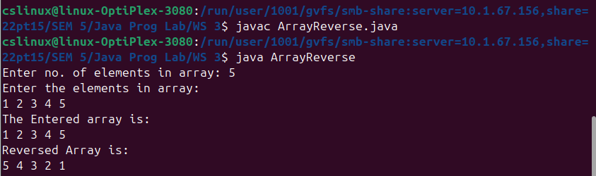

—---------------------------------------------------------------------------------------------------------------------------

2) Write a method named minGap that accepts an integer array as a parameter and returns the minimum 'gap' between adjacent values in the array. The gap between two adjacent values in an array is defined as the second value minus the first value.

import java.util.Scanner;

public class minGap {
public static void main(String args[]) {

Scanner obj = new Scanner(System.in);

System.out.print("Enter no. of elements in array: ");
int n = obj.nextInt();

int[] arr = new int[n];
System.out.println("Enter the elements: ");
for(int i=0;i<n;i++) {
arr[i] = obj.nextInt();
}

double min = Double.POSITIVE_INFINITY;
for(int i=0;i<n-1;i++) {
int t = arr[i+1] - arr[i];
if (t < min) {
min = t;
}
}

System.out.println("Min Gap is: " + (int)min);
obj.close();
}
}

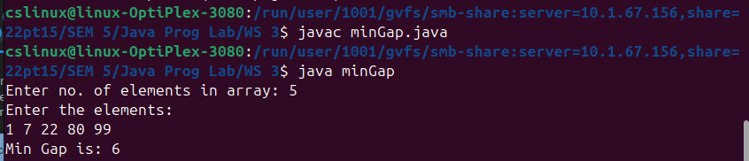

—---------------------------------------------------------------------------------------------------------------------------

3) Given a positive integer n, generate an n x n matrix filled with elements from 1 to n^2 in spiral order and print the element.
Input: n = 3
Output: [[1,2,3],[8,9,4],[7,6,5]]

import java.util.Scanner;

public class SpiralMatrix {
public static void main(String args[]) {

Scanner obj = new Scanner(System.in);

System.out.print("Enter n: ");
int n = obj.nextInt();

int[][] mat = new int[n][n];

int top=0, bottom=n-1, left=0, right=n-1;
int value = 1;
while (value <= n*n)
{
for(int i=left; i<=right; i++) {
mat[top][i] = value;
value++;
}
top++;

for(int i=top; i<=bottom; i++) {
mat[i][right] = value;
value++;
}
right--;

if(top <= bottom) {
for(int i=right; i>=left; i--) {
mat[bottom][i] = value;
value++;
}
bottom--;
}

if(left <= right) {
for(int i=bottom; i>=top; i--) {
mat[i][left] = value;
value++;
}
left++;
}
}

System.out.println("Spiral matrix: ");
System.out.print("[ ");
for(int i=0;i<n;i++) {
System.out.print("[");
for(int j=0;j<n;j++) {
System.out.print(" " + mat[i][j]);
}
System.out.print(" ],");
}
System.out.println(" ]");

System.out.printf("\n");
for(int i=0;i<n;i++) {
for(int j=0;j<n;j++) {
System.out.print(mat[i][j] + "\t");
}
System.out.println("");
}

obj.close();
}
}

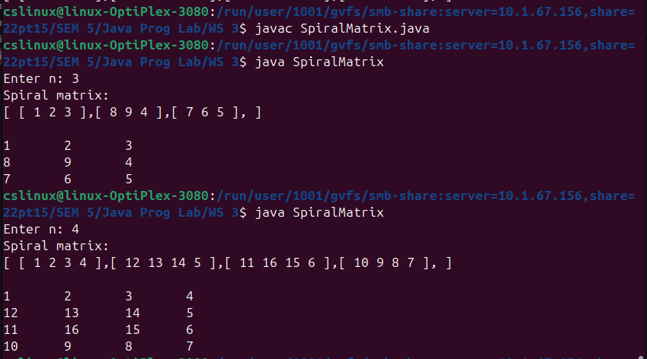
—---------------------------------------------------------------------------------------------------------------------------

4) Write a menu driven program to do following operation on two dimensional array A of size
m x n. You should use user-defined methods which accept 2-D array A, and its size m and n
as arguments. The options are:
To input elements into matrix of size m x n
To display elements of matrix of size m x n
Sum of all elements of matrix of size m x n
To display row-wise sum of matrix of size m x n
To display column-wise sum of matrix of size m x n
To create transpose of matrix of size n x m

import java.util.Scanner;

public class Matrix_Operations {

public static int[][] input(Scanner obj,int mat[][], int m, int n) {
System.out.printf("Input elements into matrix of size %d x %d: \n",m,n);
for(int i=0;i<n;i++) {
for(int j=0;j<n;j++) {
mat[i][j] = obj.nextInt();
}
}
return mat;
}

public static void display(int mat[][], int m, int n) {
System.out.println("Displaying the matrix: ");
for(int i=0;i<n;i++) {
for(int j=0;j<n;j++) {
System.out.print(mat[i][j] + "\t");
}
System.out.println("");
}
}

public static void sumAll(int mat[][], int m, int n) {
System.out.print("Sum of all the elements of matrix: ");
int sum = 0;
for(int i=0;i<n;i++) {
for(int j=0;j<n;j++) {
sum += mat[i][j];
}
}
System.out.print(sum);
System.out.println("");
}

public static void rowSum(int mat[][], int m, int n) {
System.out.println("Row-wise Sum of matrix: ");
int sum = 0;
for(int i=0;i<n;i++) {
for(int j=0;j<n;j++) {
sum += mat[i][j];
}
System.out.printf("Sum of Row %d: %d\n", i+1, sum);
sum=0;
}
System.out.println("");
}

public static void colSum(int mat[][], int m, int n) {
System.out.println("Column-wise Sum of matrix: ");
int sum = 0;
for(int j=0;j<n;j++) {
for(int i=0;i<n;i++) {
sum += mat[i][j];
}
System.out.printf("Sum of Column %d: %d\n", j+1, sum);
sum=0;
}
System.out.println("");
}

public static void transpose(int mat[][], int m, int n) {
System.out.println("Transpose of matrix: ");
int[][] transposed_matrix = new int[m][n];

for(int i=0;i<n;i++) {
for(int j=0;j<n;j++) {
transposed_matrix[j][i] = mat[i][j];
}
}

for(int i=0;i<n;i++) {
for(int j=0;j<n;j++) {
System.out.print(transposed_matrix[i][j] + "\t");
}
System.out.println("");
}
}

public static void main(String args[]) {

Scanner obj = new Scanner(System.in);

System.out.print("Enter no. of rows: ");
int m = obj.nextInt();
System.out.print("Enter no. of columns: ");
int n = obj.nextInt();
int[][] mat = new int[m][n];
int ch = 0;

while(ch!=7) {

System.out.printf("\nMatrix operations: \n");
System.out.println("1. Input the elements in matrix");
System.out.println("2. Display the elements of matrix");
System.out.println("3. Sum of all the elements of matrix");
System.out.println("4. Display the row-wise sum of matrix");
System.out.println("5. Display the Column-wise sum of matrix");
System.out.println("6. Create the Transpose of matrix");
System.out.println("7. Quit");

System.out.print("Enter your choice: ");
ch = obj.nextInt();
System.out.println("");
switch(ch) {
case 1: mat = input(obj,mat,m,n);
break;
case 2: display(mat,m,n);
break;
case 3: sumAll(mat,m,n);
break;
case 4: rowSum(mat,m,n);
break;
case 5: colSum(mat,m,n);
break;
case 6: transpose(mat,m,n);
break;
case 7: break;
default: System.out.println("Enter the valid choice!");
}

}

obj.close();
}
}

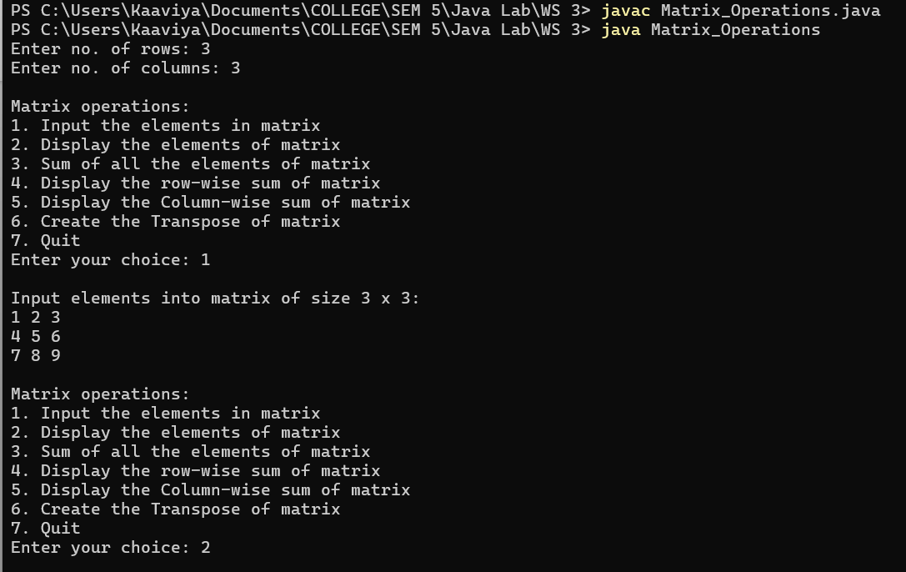

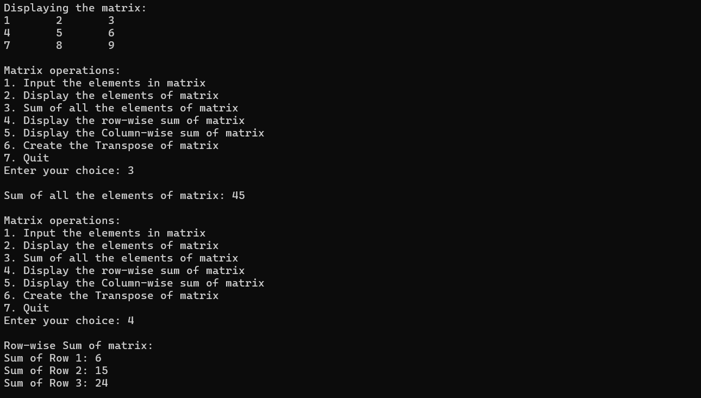
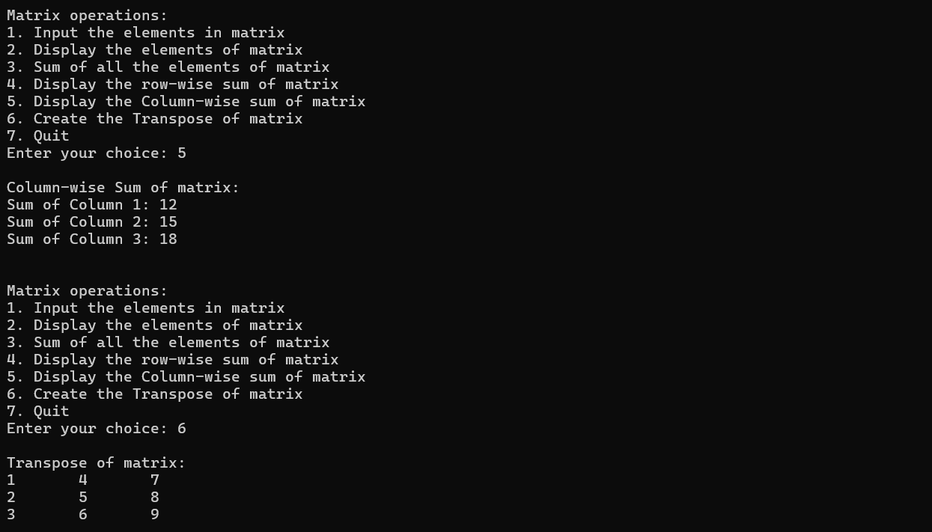
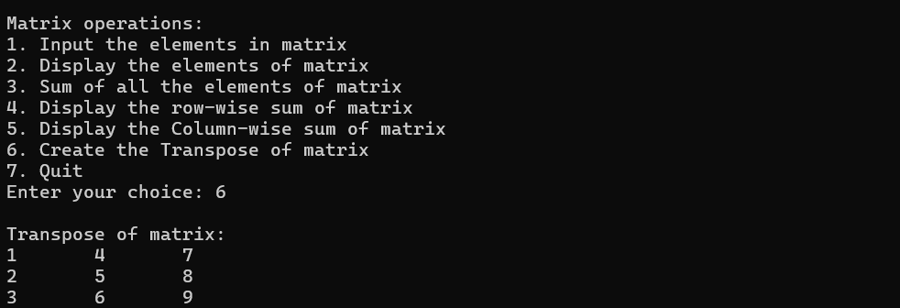

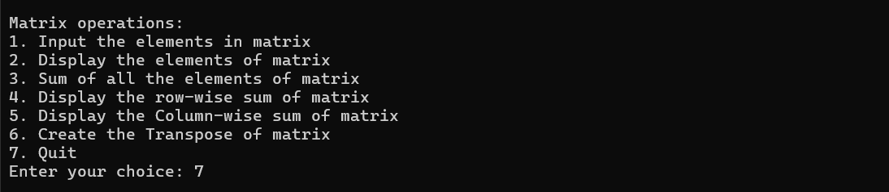

—---------------------------------------------------------------------------------------------------------------------------

5) The Huntington High School basketball team has five players named Art, Bob, Cal, Dan, and
Eli. Accept the number of points scored by each player in a game and create a bar chart that
illustrates the points scored by displaying an asterisk for each point.

import java.util.Scanner;

public class BarChart {
public static void main(String args[]) {

Scanner obj = new Scanner(System.in);

System.out.print("Enter no. of players: ");
int n = obj.nextInt();

int points[] = new int[n];
String names[] = new String[n];

System.out.print("Enter names of the players: ");
for(int i=0; i<n; i++) {
names[i] = obj.next();
}
System.out.printf("\n");

for(int i=0; i<n; i++) {
System.out.print("Enter points earned by " + names[i] + " >> ");
points[i] = obj.nextInt();
}
System.out.printf("\n\n");

System.out.printf("Points for Game: \n");
for(int i=0; i<n; i++) {
System.out.print(names[i] + " " );
for(int j=0; j<points[i]; j++) {
System.out.print("*");
}
System.out.println();
}

obj.close();

}
}

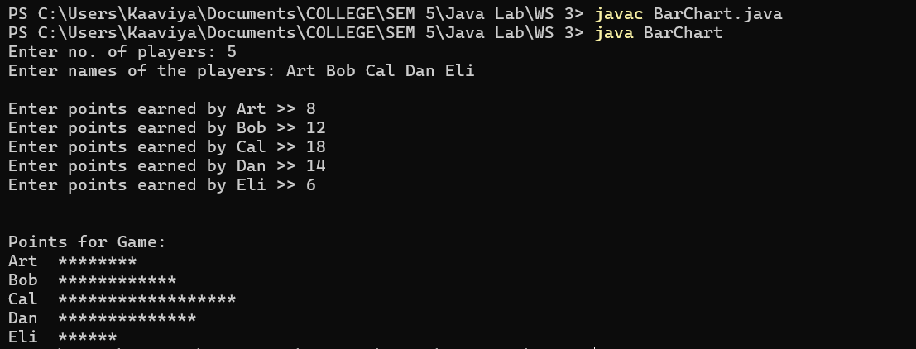

—---------------------------------------------------------------------------------------------------------------------------
6) You have been given a long type array/list of size N contains non-negative integers
representing an elevation map where the width of each bar is 1, compute how much water it
can trap after raining.
Input: height = [0,1,0,2,1,0,1,3,2,1,2,1]
Output: 6

import java.util.Scanner;
import java.lang.Math;

public class MaxRainwater {

public static void main(String args[]) {

Scanner obj = new Scanner(System.in);

System.out.print("Enter n: ");
int n = obj.nextInt();
int arr[] = new int[n];
System.out.print("Enter the elements: ");
for(int i=0; i<n; i++) {
arr[i] = obj.nextInt();
}

int res = 0;
for(int i=1; i<n-1; i++) {

int left = arr[i];
for(int j=0; j<i; j++) {
left = Math.max(left,arr[j]);
}

int right = arr[i];
for(int j=i+1; j<n; j++) {
right = Math.max(right,arr[j]);
}

res += Math.min(left,right) - arr[i];
}

System.out.println("Maximum rain water trapped: " + res);
obj.close();
}
}

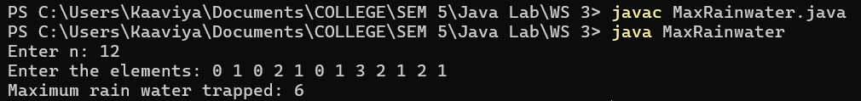

—---------------------------------------------------------------------------------------------------------------------------

7) You are given an array prices where prices[i] is the price of a given stock on the ith day. You
want to maximize your profit by choosing a single day to buy one stock and choosing a
different day in the future to sell that stock. Return the maximum profit you can achieve from
this transaction. If you cannot achieve any profit, return 0.
Input: prices = [7,1,5,3,6,4]
Output: 5
Explanation: Buy on day 2 (price = 1) and sell on day 5 (price = 6), profit = 6-1 = 5.
Note that buying on day 2 and selling on day 1 is not allowed because you must buy before
you sell.

import java.util.Scanner;

public class Maximize_Profit {

public static void main(String args[]) {

Scanner obj = new Scanner(System.in);

System.out.print("Enter no. of pieces: ");
int n = obj.nextInt();
int pieces[] = new int[n];
System.out.print("Enter the price of the prices: ");
for(int i=0; i<n; i++) {
pieces[i] = obj.nextInt();
}
System.out.printf("\n");

int minValue = pieces[0];
int minIndex = -1;
for(int i=0; i<pieces.length; i++) {
if(pieces[i] < minValue) {
minValue = pieces[i];
minIndex = i;
}
}

int maxValue = pieces[minIndex+1];
for(int i=(minIndex+1); i<pieces.length; i++ ) {
if(pieces[i] > maxValue) {
maxValue = pieces[i];
}
}

System.out.println("Max Profit: " + (maxValue-minValue));

obj.close();
}
}

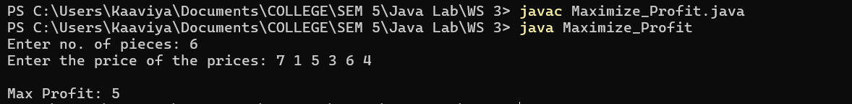

—---------------------------------------------------------------------------------------------------------------------------
8) Given an array of integers heights representing the histogram's bar height where the width of
each bar is 1, Write a program to find the area of the largest rectangle in Histogram.
Example:
Input: heights = [2,1,5,6,2,3]
Output: 10

import java.util.Scanner;
import java.lang.Math;

public class LargestRectangle {
public static void main(String[] args) {

Scanner obj = new Scanner(System.in);

System.out.print("Enter n: ");
int n = obj.nextInt();
int arr[] = new int[n];
System.out.print("Enter the elements: ");
for(int i=0; i<n; i++) {
arr[i] = obj.nextInt();
}

int left[]=new int[n]; //to find the leftmost position of the width by finding the nearest left height that is smaller than the curr height
int right[]=new int[n]; //to find the rightmost position of the width by finding the nearest right height that is smaller than the curr height

left[0] = -1; //index
right[n-1] = n; //index

for(int i=1; i<n; i++) {
int prev = i-1;
while(prev >=0 && arr[prev] >= arr[i]) {
prev = left[prev];
}
left[i] = prev;
}

for(int i=n-2; i>=0; i--) {
int next = i+1;
while(next < n && arr[next] >= arr[i]) {
next = right[next];
}
right[i] = next;
}

int maxArea = 0;

for(int i=0; i<n; i++) {
int width = right[i] - left[i] - 1;
int area = width * arr[i];

maxArea = Math.max(maxArea, area);
}

System.out.println("Area of the largest Rectangle in Histogram: " + maxArea);
obj.close();
}
}

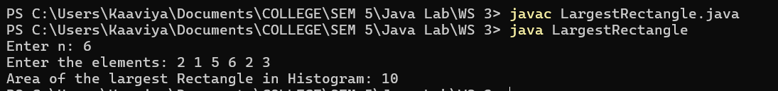

—---------------------------------------------------------------------------------------------------------------------------

9) You are given a 0-indexed integer array nums of even length consisting of an equal number of positive and negative integers. You should rearrange the elements of nums such that the modified array follows the given conditions:
Every consecutive pair of integers have opposite signs.
For all integers with the same sign, the order in which they were present in nums is preserved. The rearranged array begins with a positive integer.
Return the modified array after rearranging the elements to satisfy the aforementioned conditions.

import java.util.Scanner;
import java.util.ArrayList;
import java.util.List;

public class RearrangeArray {
public static void main(String[] args) {

Scanner obj = new Scanner(System.in);

System.out.print("Enter n: ");
int n = obj.nextInt();
int arr[] = new int[n];
System.out.print("Enter the elements: ");
for(int i=0; i<n; i++) {
arr[i] = obj.nextInt();
}

List<Integer> positive_nums = new ArrayList<>();
List<Integer> negative_nums = new ArrayList<>();
for(int num : arr) {
if(num > 0)
positive_nums.add(num);
else
negative_nums.add(num);
}

int[] rearranged = new int[n];
int pos=0;
int neg=0;
for (int i=0; i<n; i++) {
if(i%2==0)
rearranged[i] = positive_nums.get(pos++);
else
rearranged[i] = negative_nums.get(neg++);
}

System.out.println("Rearranged array: ");
for (int num : rearranged) {
System.out.print(num + " ");
}
System.out.println();

obj.close();

}
}

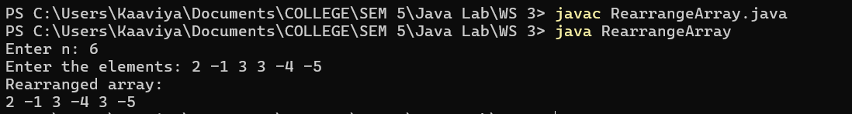

—---------------------------------------------------------------------------------------------------------------------------

10) Zeller's congruence is an algorithm developed by Christian Zeller to calculate the day of the
week. The formula is,
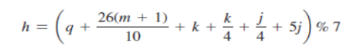
where,
h is the day of the week (0: Saturday, 1: Sunday, 2: Monday, 3: Tuesday, 4: Wednesday,
5: Thursday, 6: Friday).
q is the day of the month.
m is the month (3: March, 4: April, ..., 12: December). January and February are counted
as months 13 and 14 of the previous year.
j is the century (i.e., year 100 ).
k is the year of the century (i.e., year % 100).
Note that the division in the formula performs an integer division. Write a program that
prompts the user to enter a year, month, and day of the month, and displays the name of the
day of the week.

import java.util.Scanner;

public class ZellersCongruence {
public static void main(String[] args) {

Scanner obj = new Scanner(System.in);

System.out.print("Enter year (e.g., 2023): ");
int year = obj.nextInt();
System.out.print("Enter month (1-12): ");
int month = obj.nextInt();
System.out.print("Enter day of the month (1-31): ");
int day = obj.nextInt();

if(month < 12) {
month += 12;
year -= 1;
}

int q = day;
int m = month;
int j = year/100;
int k = year%100;

int h = (q + (26*(m+1))/10 + k + (k/4) + (j/4) + 5*j) % 7;

String[] weekDays = {"Saturday", "Sunday", "Monday", "Tuesday", "Wednesday", "Thursday", "Friday"};

System.out.println("Day of the week is " + weekDays[h]);

obj.close();
}
}





